Solve the following word problems using exponential functions.

Follow these steps when solving these problems:

1. Read the question carefully.
2. Underline what you are looking for (usually the question!)
3. Write an equation the represents the situation. **Be sure to define your variables!**
4. Use your equation to find the answer.
5. Write your answer in a sentence. Does your answer make sense? Check your units.
6. In 1971, there were 294,105 female students participating in high school sports. Since then that number has tripled each year.
   1. Write an equation to represent the number of female students participating in high school sports since 1971. **Be sure to define your variables!**
   2. Is this an example of exponential growth or decay?
   3. How many females would be participating **today**?
7. In Math class, if you do not do your homework you will only learn th of the topics from that day. We complete 160 topics during the course of the year.
   1. Write an equation that models how much you learn after x days. **Be sure to define your variables!**
   2. Is this an example of exponential growth or decay?
   3. If you don’t do your homework, how many topics would you learn after 3 weeks?
8. Suppose a rabbit population of 10 rabbits quadrupled every month.
   1. Write an exponential equation to represent the rabbit population after x months. **Be sure to define your variables!**
   2. Use your equation to complete the following table of values

|  |  |  |  |  |  |  |  |
| --- | --- | --- | --- | --- | --- | --- | --- |
| Months | 0 | 1 | 2 | 3 | 4 | 6 | 12 |
| # of Rabbits |  |  |  |  |  |  |  |

* 1. Use your table and graph the values below. Remember x represents the # of months, and y represents the # of rabbits.

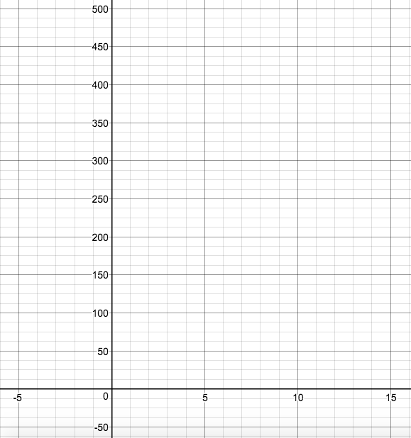

* 1. What is the total number of rabbits after 2 years? Write your solution in scientific notation.

1. Each year the local country club sponsors a tennis tournament. Play starts with 128 participants. During each round, half of the players are eliminated. How many players remain after 5 rounds?
2. You invest $200 when you turn 18 years old. You are told that your money will double every four years. How much money will you have when you are 42 years old?

Review:

1. Simplify

a.  b.  c. 

1. Write each number in scientific notation.

a. 0.00375 b. 50000 c. 57.9

8. Perform the operations and express your answer in scientific notation.

a.  b. 

1. True or False. State whether each inequality is true or false.

a.  b.  c.  d. 