1. Place each of the following radicals onto the number line below in order of smallest to largest.

a. 

b. 

c. 

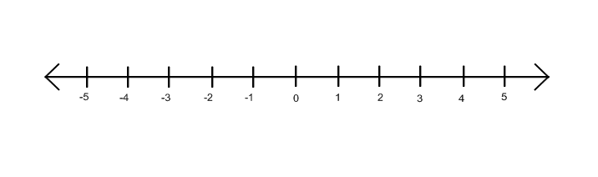d. 

e. 

2. Write the following numbers in scientific notation.

1. 8,450,000,000,000,000
2. 0.000000056

3. Perform the following operations and express your answer in scientific notation.

1.  b. 

4. Simplify the expressions below.

1.  b. 