Name: _______________________________ Math 620 B Block
Date:____________________ Exponents and Radicals Unit

Homework Due: Monday, May 15

- The table below shows figures composed of circles. The number of circles in each figure follows a pattern, as shown.

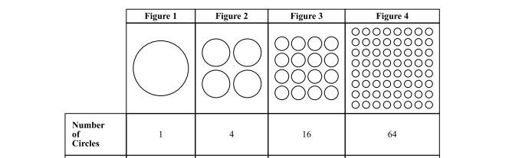

- Predict the number of circles in Figure 5. Show or explain how you got your answer.

- Determine the ratio of the number of circles in figure 2 to figure 1
(Ratio = #circles figure 2 / # circle figure 1).

- Do the same for each pair for figures:
Ratio number of circles in Figure 3 to Figure 2:

Ratio number of circles in Figure 4 to Figure 3:

- What is the pattern? Explain how you would find the number of circles in figure 10.
- Maya leaves school to go home. She walks 6 blocks North and then 8 blocks west.
How far is Maya from the school?

Use the Pythagorean Theorem to help you solve Maya’s distance from school. (Remember a² + b² = c²)
START

6
END
8

Solution: Maya is _______________________ blocks from school.

