1. What is the equation of the line in the graph below?

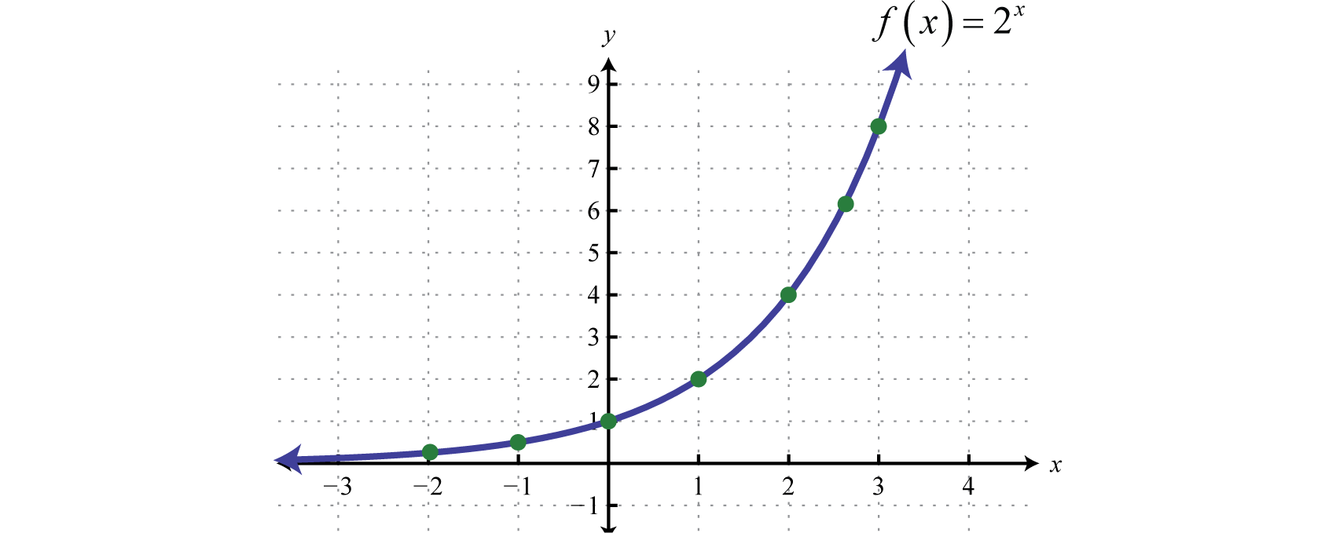

Does the graph model exponential growth or decay?

2. Identify the starting amount in each formula below, and state whether the formula models exponential growth or exponential decay. Explain your reasoning.

* 1. initial value: _______________ growth or decay?

$f(t)=200{\left(\frac{5}{3}\right)}^{t}$ ___________________
  2. initial value: _______________ growth or decay?

$f(t)= \frac{2}{3}({3)}^{t}$ ___________________
  3. initial value: _______________ growth or decay? ___________________

3. Order the expressions below from smallest to largest using inequalities.

a.  b. 

c.  d. 

4. Ryan bought a new computer for $\$2,100$. The value of the computer decreases by $50\%$ each year. When will the value drop below $\$300$?

|  |  |  |  |
| --- | --- | --- | --- |
| year | Computer value | 50% decrease | New computer value |
| 1 | $2,100 |  |  |
| 2 |  |  |  |
| 3 |  |  |  |
| 4 |  |  |  |
| 5 |  |  |  |

What is the constant multiplier?

What is the equation that models the value of the computer? (Hint use  where a is the initial value and b is the constant multiplier)

What if Ryan had the option to calculate the value of his new computer by decreasing the value at a set rate of $300 per year. Should he take this option? Explain your reasoning using mathematics.

____________________________________________________________

5. Simplify the following.

a. (= b. (4 x 106) - (2 x 105) =

c.  d. 